## CI/CD

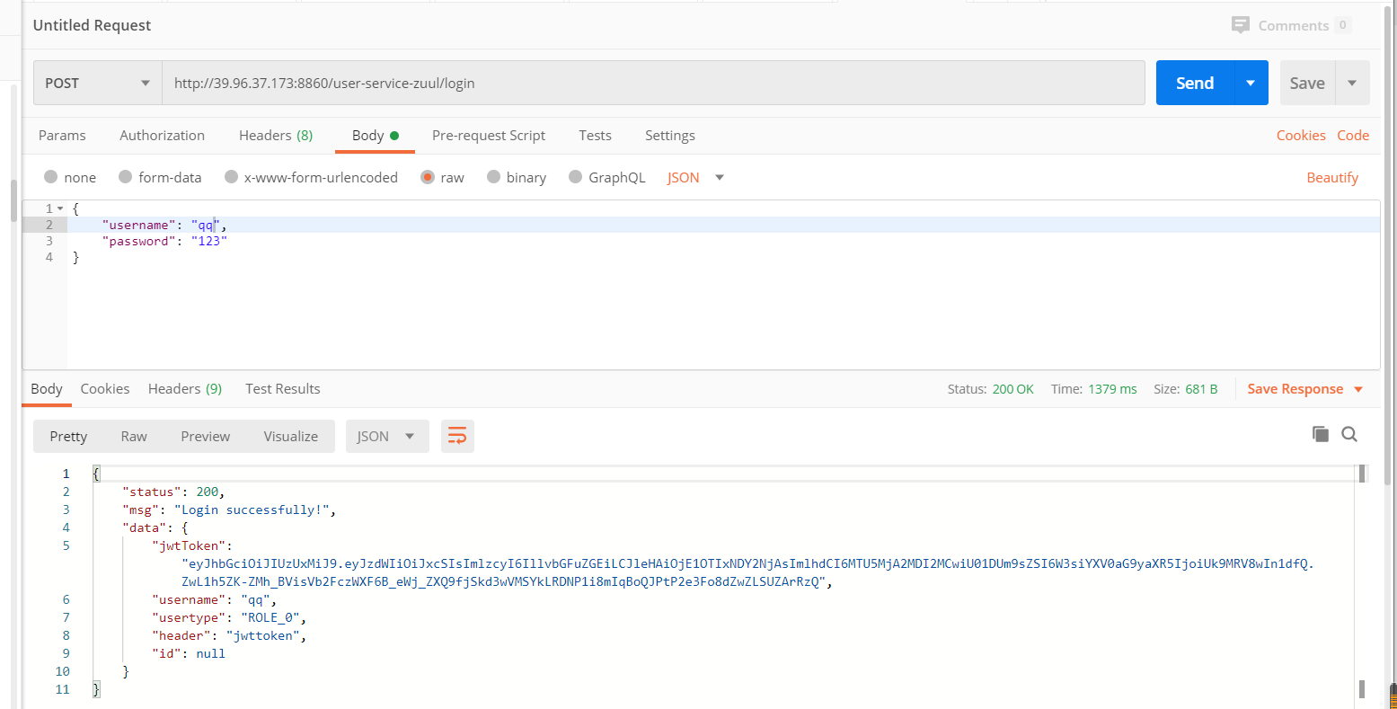

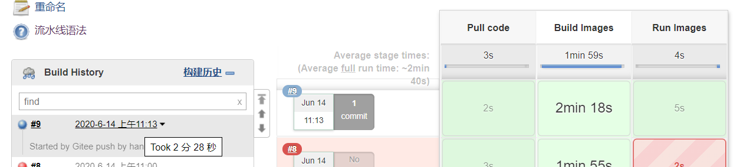



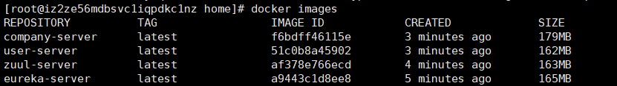

## Jenkinsfile

**def git_auth = "665ed1ba-8719-4ead-93b7-076842d47e78"**

**node {**

**stage('Pull code') {**

**checkout([$class: 'GitSCM', branches: [[name: '*/master']], doGenerateSubmoduleConfigurations: false, extensions: [], submoduleCfg: [], userRemoteConfigs: [[credentialsId: "${git_auth}", url: 'https://gitee.com/hanpxg/socke-market.git']]])**

**}**

**stage('Build Images') {**

**sh "mvn -f common-server clean install"**

**sh "mvn -f eureka-server clean package dockerfile:build"**

**sh "mvn -f zuul-server clean package dockerfile:build"**

**sh "mvn -f user-server clean package dockerfile:build"**

**sh "mvn -f company-server clean package dockerfile:build"**

**}**

**stage('Run Images') {**

**sh "docker run -d --name=eureka-server -p 8761:8761 eureka-server"**

**sh "docker run -d --name=user-server -p 8859:8859 user-server"**

**sh "docker run -d --name=company-server -p 8857:8857 company-server"**

**sh "docker run -d --name=zuul-server -p 8860:8860 zuul-server"**

**}**

**}**

## Dockerfile

**pom.xml**

**<plugin>**

**<groupId>com.spotify</groupId>**

**<artifactId>dockerfile-maven-plugin</artifactId>**

**<version>1.3.6</version>**

**<configuration>**

**<repository>${project.artifactId}</repository>**

**<buildArgs>**

**<JAR_FILE>target/${project.build.finalName}.jar</JAR_FILE>**

**</buildArgs>**

**</configuration>**

**</plugin>**

**Dockerfile**

**FROM openjdk:8-jdk-alpine**

**ARG JAR_FILE**

**COPY ${JAR_FILE} app.jar**

**EXPOSE 8761**

**ENTRYPOINT ["java","-jar","/app.jar"]**

## JMeter

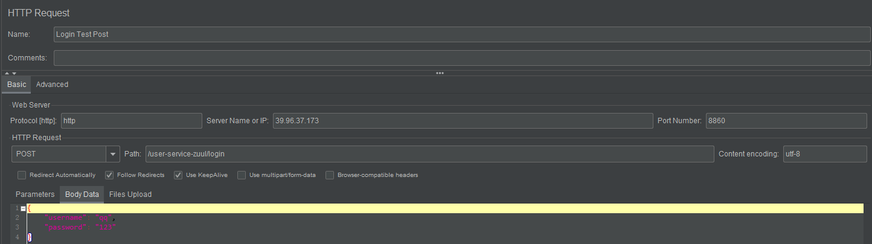

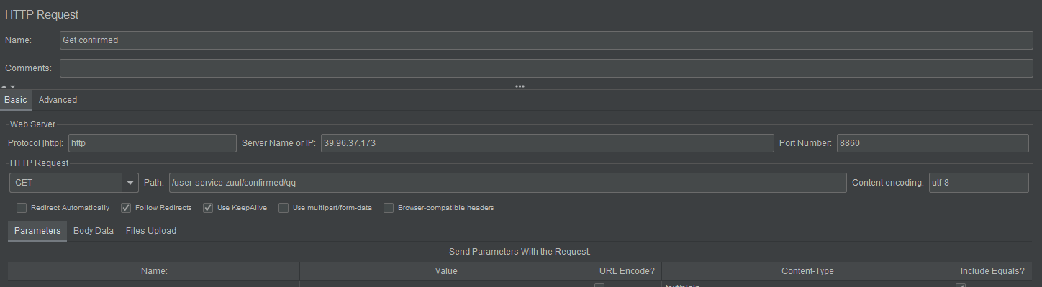

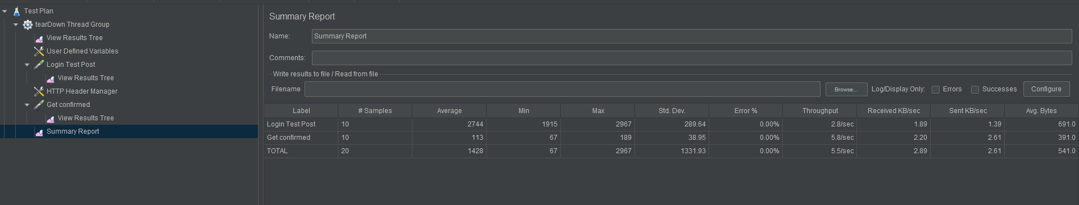

## Dockerized

**sudo docker pull registry.cn-hangzhou.aliyuncs.com/socket-market/socket:0.1**

**公网地址**

**registry.cn-hangzhou.aliyuncs.com/socket-market/socket**

